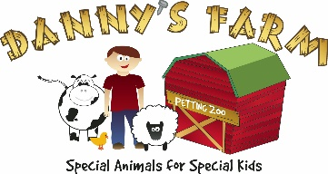
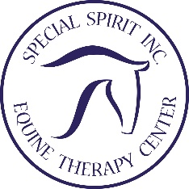

Child___________________________________
I authorize Special Spirit/Danny’s Farm, LLC, to publish photographs taken of myself and/or the minor child or children listed above, and our names and likenesses, for use in Special Sprit/Danny’s Farm, LLC’s print, online and video-based marketing materials, as well as other Company publications. By signing this form, I acknowledge that participation is voluntary and that neither I, the minor child, or minor children will receive financial compensation of any type associated with the taking or publication of these photographs or participation in company marketing materials or other Company publications. I hereby release Special Spirit/Danny’s Farm, LLC, its contractors, its employees and any third parties involved in the creation or publication of Company publications, from liability for any claims by me or any third party in connection with my participation or the participation of the minor children listed below. I understand that this agreement contains a promise not to sue Special Spirit/Danny’s Farm, LLC or their employees. Date: Printed Name of Children: Printed Name of Adult(s): Signature:

Child____________________________________________

Guardian of Child_________________________________

Date____________________________________________

Signature________________________________________

